**Chapter 26: Magnets and Magnetic Fields**

***Please remember to photocopy 4 pages onto one sheet by going A3→A4 and using back to back on the photocopier.***

**Questions to make you think**

1. Given three identical iron bars, two of which are magnetic, how would you identify the non-magnetic bar (no other equipment allowed)?
2. Given two identical iron bars, one of which is magnetic, how would you identify the non-magnetic bar (no other equipment allowed)?

**Magnetic poles** exist in pairs, called the North Pole and the South Pole.

Like poles repel, unlike poles attract.



**A Magnetic Field** is any region of space where magnetic forces can be felt.

You must also remember that magnetic field lines always go from the North Pole to the South Pole.

**Demonstration of a Magnetic Field due to Current** in:

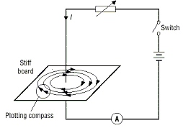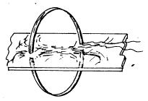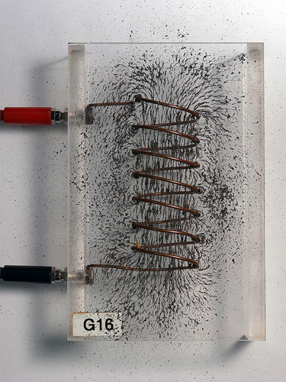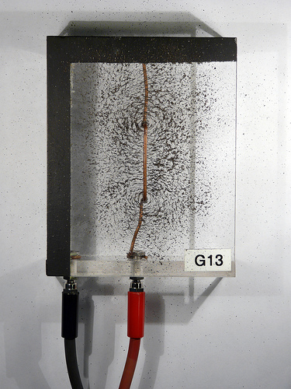(i) A Long Straight Wire (ii) A Loop (iii) A Solenoid

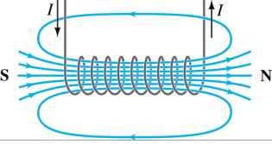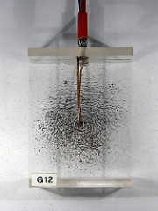

Each end of the wire is connected to a d.c. supply with high current (e.g. a car battery).

Note that to demonstrate the existence of the magnetic field we could use iron filings or small compasses.

**Determining the direction of a Magnetic Field due to an Electric Current:**

1. **For a straight wire** **use** **the right hand grip rule**:

Grip the conductor in your right hand, with your thumb pointing in the direction of the current; your fingers now indicate the direction of the magnetic field lines.

1. **For a solenoid**:

The easiest way of remembering the direction of the magnetic field in a solenoid is to note that when looking into a loop or solenoid, if the current is moving in a Clockwise direction then the pole facing you is a South Pole (CIS (kiss?)); anti-clockwise represents a North Pole.

**To Demonstrate the Magnetic Effect of an Electric Current: The Electromagnet**

An electromagnet consists of a soft iron core in a solenoid. When the current is switched on the core acts as a magnet and can be used to pick up nails.

(A solenoid is a coil of wire whose length is much longer than its radius).

**Uses of Electromagnets**

1. Electromagnets can be used in scrap yards to lift cars.
2. They are also used in electric motors, loudspeakers and electromagnetic relays (eg in doorbells).

**The Earth’s Magnetic Field\***

* The Earth’s magnetic field can be used for accurate navigation, both by man and animal*.
* Magnetic fields protect the Earth from dangerous radiation from the sun (see the related link on the website)

**Leaving Cert Physics Syllabus**

|  |  |  |  |
| --- | --- | --- | --- |
| **Content** | **Depth of Treatment** | **Activities** | **STS** |
| **1. Magnetism** | Magnetic poles exist in pairs.  Magnetic effect of an electric current. | Demonstration using magnets, coils, and nails. | Electromagnets and their uses. |
|  |  |  |  |
| **2. Magnetic fields** | Magnetic field due to  • magnets  • current in  - a long straight wire  - a loop  - a solenoid.  Description without mathematical details.  Vector nature of magnetic field to be stressed. | Demonstrations. | Earth’s magnetic field.  Using Earth’s magnetic field in navigation i.e. compasses. |

***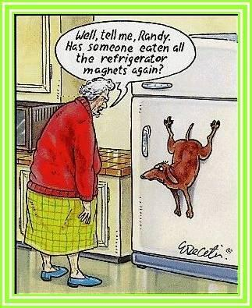* Extra Credit**

**\*The Earth’s Magnetic Field**

The origin of the Earth’s magnetic field is still unknown, although the consensus appears to be that it is probably caused by electric currents circulating in the molten outer part of the iron-rich core of the planet, which is at a temperature of at least 2200 °C. Either way, the situation today is that it acts as though there is a bar magnet in the centre of the Earth, with its *South end* up beside our *Geographic North Pole*.

This is why the north pole of our magnets point there (a little confusing, isn’t it?).

However the magnetic North Pole is not directly in line with the geographic North Pole, and the difference gets bigger as you travel further north (or south) of the equator (see diagram).

This difference is known as *magnetic variation*, and once the angle is known, the Earth’s magnetic field can be used for accurate navigation.

But this arrangement is not immutable over geologic timescales.

Every 500,000 years or so the system “flips”, and the magnetic field undergoes complete reversal; the north magnetic pole becomes the south and vice versa.

The last time this happened was about three quarters of a million years ago, so one might infer that a flip is overdue.

Some scientists, indeed, have been bold enough to predict that it will occur suddenly somewhere around 2,000 years from now.

It’s much more likely however that the flip, whenever it may come, while ‘sudden’ on a geologic timescale, would actually be much more gradual, taking perhaps 1,000 years or more.

This view is supported by the fact that no major species extinctions have been associated with the last magnetic field reversal 750,000 years ago.

So how do scientists know that magnetic field reversals have occurred in the past?

Most of the evidence lies on the ocean floor.

As some continental plates sink below the surface, new material emerges from under the sea-bed and as it reaches the surface it spreads our like a freshly laid carpet. This occurs very slowly.

As the magnetic field of the Earth changes, it gets recorded in the way iron orientates itself with the material.

So simply going over the ‘carpet’ with a magnetic compass results in the compass switching direction at regular intervals.

Knowing how quickly the material spreads leads to a determination of the time intervals between magnetic flips.

What would happen if the molten iron inside the Earth were to cease to slosh around completely?

For starters there would be no magnetic field. And the consequences of this?

Without the protection of the magnetic field life on Earth, including life for all human beings, would be greatly subject to greatly enhanced and very harmful cosmic radiation; satellites would be nudged from orbit; the climatic consequences could well be dramatic.

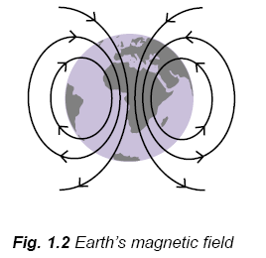**\*The Earth’s magnetic field can be used for accurate navigation, both by man and animal.**

Bird Migration

Many migratory birds such as swallows have a mineral in their brains known as *magnetite*, which helps them navigate as they travel across the oceans.

It has also been shown recently that sharks are sensitive to magnetic fields. Scientists put a number of hammerhead sharks into a pool which they surrounded with copper wire. When they turned on the current through the wire there was a noticeable change in behaviour of the sharks.

**Fatal Attraction: Magnetic Mysteries of the Enlightenment**

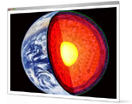Magnets were associated with sex: the French word aimant means either magnet or lover; William Gilbert, in 1600, coined the vocabulary of male and female poles; magnets could lure lovers or keep a spouse faithful; even now, someone with a magnetic personality can ‘pull’.

Such explanations as there were relied on loose phrases such as the ‘power of sympathy’. But the lodestone business was a serious one: magnetic forces (people thought for a while) held the world together, and they certainly kept navigators pointing in the right direction.

Edmond Halley, he of the comet, began what became a systematic study of compass variation, and quickly calculated that the Earth was one huge ball of magnetism, and proposed that its interior might not only be hollow, but even populated – an idea that seeped into romance, satire and (long afterwards) science fiction.

Taken from *The* *New Scientist* magazine

**Exam Questions**

1. [2003 OL][2005 OL][2006 OL][2009 OL]

What is a magnetic field?

1. [2006 OL]

Describe an experiment to show the magnetic field due to a current in a solenoid.

1. [2009 OL]

Describe an experiment to show the shape of the magnetic field around a U-shaped magnet.

1. [2005 OL][2007 OL][2010 OL]

Draw a sketch of the magnetic field around a bar magnet.

1. [2005][2003 OL]

Draw a sketch of the magnetic field due to a long straight current-carrying conductor.

Your diagram should show the direction of the current and the direction of the magnetic field.

1. [2002 OL]

The diagram shows a U-shaped magnet. Copy the diagram and show on it the magnetic field lines due to the magnet.

1. [2004][2003 OL]

Give one use of the earth’s magnetic field.

1. [2007]

Why does a magnet that is free to rotate point towards the North?

1. [2006 OL]

A solenoid carrying a current and containing an iron core is known as an electromagnet.

Give one use of an electromagnet.

1. [2006 OL]

State one advantage of an electromagnet over an ordinary magnet.

**Exam Solutions**

1. A Magnetic Field is any region of space where magnetic forces can be felt.
2. 

* Apparatus: power source, solenoid, closed circuit, iron filings
* Procedure:

Place a piece of paper over the solenoid and sprinkle the iron filingsonto the paper.

Turn on the current.

* Observation: iron filings rearrange themselves in two semi-circular patterns around the solenoid.

1. Apparatus: U-shaped magnet, iron filings

Procedure: Place a piece of paper over the magnet and sprinkle the iron filingsonto the paper.

Observation: note the shape of the collection of iron filings near the poles of the magnet.

1. ****See diagram
2. See diagram
3. Show field lines going in straight lines from North to South.
4. Navigation, protective layer around the earth which deflects dangerous cosmic rays (sometimes called solar winds).
5. It is the north end of the magnet which is being attracted to the south-end of the Earth’s magnetic field (which is located at what we call the north pole).
6. Electric bell / scrap yard crane / speaker / doorbell.
7. It can be turned on and off.

***“Who would not be amazed at this virtue of the stone?”***

*Augustine*

*“The diamond is a stone possessed by many among ourselves, especially by jewellers and lapidaries, and the stone is so hard that it can be wrought neither by iron nor fire, nor, they say, by anything at all except goat’s blood.  But do you suppose it is as much admired by those who own it and are familiar with its properties as by those to whom it is shown for the first time?  Persons who have not seen it perhaps do not believe what is said of it, or if they do, they wonder as at a thing beyond their experience; and if they happen to see it, still they marvel because they are unused to it, but gradually familiar experience [of it] dulls their admiration.  We know that the loadstone has a wonderful power of attracting iron.  When I first saw it I was thunderstruck, for I saw an iron ring attracted and suspended by the stone; and then, as if it had communicated its own property to the iron it attracted, and had made it a substance like itself, this ring was put near another, and lifted it up; and as the first ring clung to the magnet, so did the second ring to the first.  A third and a fourth were similarly added, so that there hung from the stone a kind of chain of rings, with their hoops connected, not interlinking, but attached together by their outer surface.  Who would not be amazed at this virtue of the stone, subsisting as it does not only in itself, but transmitted through so many suspended rings, and binding them together by invisible links?  Yet far more astonishing is what I heard about this stone from my brother in the episcopate, Severus bishop of Milevis.  He told me that Bathanarius, once count of Africa, when the bishop was dining with him, produced a magnet, and held it under a silver plate on which he placed a bit of iron; then as he moved his hand with the magnet underneath the plate, the iron upon the plate moved about accordingly.  The intervening silver was not affected at all, but precisely as the magnet was moved backwards and forwards below it, no matter how quickly, so was the iron attracted above.  I have related what I myself have witnessed; I have related what I was told by one whom I trust as I trust my own eyes.  Let me further say what I have read about this magnet.  When a diamond is laid near it, it does not lift iron; or if it has already lifted it, as soon as the diamond approaches, it drops it.  These stones come from India.  But if we cease to admire them because they are now familiar, how much less must they admire them who procure them very easily and send them to us?  Perhaps they are held as cheap as we hold lime, which, because it is common, we think nothing of, though it has the strange property of burning when water, which is wont to quench fire, is poured on it, and of remaining cool when mixed with oil, which ordinarily feeds fire.”*

<http://discovermagazine.com/2008/may/02-three-words-that-could-overthrow-physics#.UbsXY5wmydk>